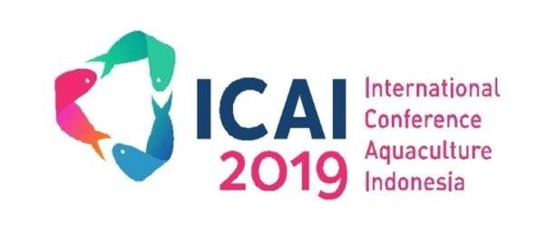

**The 9*th International Conference of Aquaculture Indonesia 2019** *October 4-5, 2019 – Surabaya, Indonesia*

**INVOICE # 04-10-2019-61**

# Invoice To:

# BUDI MULIA

Institution : PT UAB - DE HEUS INDONESIA

|  |  |  |  |
| --- | --- | --- | --- |
| **Description** | **Quantity** | **Unit Price** | **Summary** |
| BUSINESS SESSION of ICAI 2019 | 1 | 750.000 IDR | 750.000 IDR |
|  | **Total** | | **750.000 IDR** |
| **Status** | **PAID** | | |

Regards,

Dhona Indah Kiswari Management Secretariat of ICAI 2019